EMC : Hommage national à Monsieur Samuel Paty
- Ecoute attentivement les explications.

- Définis ce qu’est un hommage national.
………………………………………………………………………………………………………………………………………………………………………….
………………………………………………………………………………………………………………………………………………………………………….
………………………………………………………………………………………………………………………………………………………………………….
………………………………………………………………………………………………………………………………………………………………………….

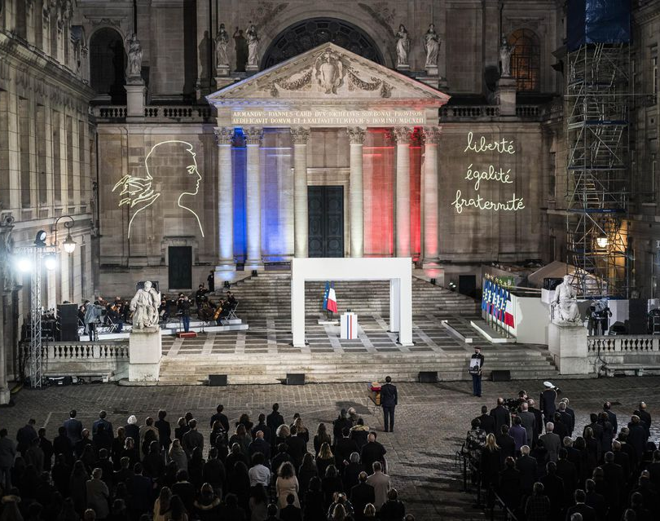
Photographie de la Cour d’honneur de la Sorbonne où a eu lieu
l’hommage national à Samuel Paty le 21 octobre 2020.
https://www.liberation.fr/politiques/2020/10/22/hommage-de-macron-a-samuel-paty-nous-continuerons-professeur_1803133

- Qui était Samuel Paty ?
………………………………………………………………………………………………………………………………………………………………………….
………………………………………………………………………………………………………………………………………………………………………….
………………………………………………………………………………………………………………………………………………………………………….
………………………………………………………………………………………………………………………………………………………………………….
- Entoure et nomme les symboles de la République présents sur la photographie.

- A ton avis, pourquoi tous ces symboles sont-ils présents lors de l’hommage à Monsieur Paty ?
………………………………………………………………………………………………………………………………………………………………………….
………………………………………………………………………………………………………………………………………………………………………….
………………………………………………………………………………………………………………………………………………………………………….
………………………………………………………………………………………………………………………………………………………………………….
………………………………………………………………………………………………………………………………………………………………………….
………………………………………………………………………………………………………………………………………………………………………….

- A la suite de ce drame, quelle valeur de notre devise considères-tu comme la plus importante ? Explique pourquoi.
………………………………………………………………………………………………………………………………………………………………………….
………………………………………………………………………………………………………………………………………………………………………….
………………………………………………………………………………………………………………………………………………………………………….
………………………………………………………………………………………………………………………………………………………………………….
………………………………………………………………………………………………………………………………………………………………………….
………………………………………………………………………………………………………………………………………………………………………….
………………………………………………………………………………………………………………………………………………………………………….
………………………………………………………………………………………………………………………………………………………………………….
………………………………………………………………………………………………………………………………………………………………………….
………………………………………………………………………………………………………………………………………………………………………….
………………………………………………………………………………………………………………………………………………………………………….
………………………………………………………………………………………………………………………………………………………………………….

